Board of Water and Sewer Commissioners
TOWN OF FOXBOROUGH

70 ELM STREET
FOXBOROUGH, MASSACHUSETTS 02035

Michael P. Stanton, Chair Robert B. Worthley
Richard M. Pacella, Jr., Vice-Chair Superintendent
Robert T. Garber, Clerk Telephone 508-543-1209
Fax 508-543-1227

Hill St Tank - Update

The Foxborough DPW has awarded and finalized all contract documents for the new tank on Hill St. Preload Construction along with their sub-contractor Iannuccillo & Sons Construction will begin mobilization the week of June 14th, with work scheduled to begin the week of June 21.

Land clearing, erosion control, and temporary construction access will be the first steps in the project and take place June 21 through July 7. Construction of the tank and associated site work is scheduled for July through November. Daily construction schedule will typically be 7:00am - 4:00 pm. Below is a picture of a similar tank installed by Preload in Connecticut.

Design is being finalized on the booster system with plans and specifications being prepared to go out to bid. More information will be provided as we get closer to construction.

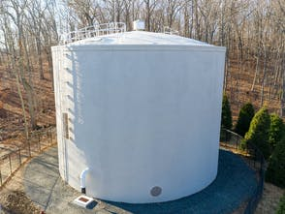

If you have any questions please call 508-543-1209 or email Bob Worthley bworthley@foxboroughma.gov, or Chris Gallagher cgallagher@foxboroughma.gov

